**Implementation FTP Client**

**FTP Client:**

import javax.swing.*;

import java.awt.*;

import java.awt.event.*;

import java.net.*;

import java.io.*;

class One extends JFrame implements ActionListener

{

/* ctrl space */

public JButton b,b1;

public JLabel l;

public JLabel l1,lmsg1,lmsg2;

One()

{

b=new JButton("Upload");

l=new JLabel("Uplaod a file : ");

lmsg1=new JLabel("");

b1=new JButton("Download");

l1=new JLabel("Downlaod a file");

lmsg2=new JLabel("");

setLayout(new GridLayout(2,3,10,10));

add(l);add(b);add(lmsg1);add(l1);add(b1);add(lmsg2);

b.addActionListener(this);

b1.addActionListener(this);

setVisible(true);

setSize(600,500);

}

public void actionPerformed(ActionEvent e)

{

try {

if (b.getModel().isArmed())

{

Socket s=new Socket("localhost",1010);

System.out.println("Client connected to server");

JFileChooser j=new JFileChooser();

int val;

val=j.showOpenDialog(One.this);

String filename=j.getSelectedFile().getName();

String path=j.getSelectedFile().getPath();

PrintStream out=new PrintStream(s.getOutputStream());

out.println("Upload");

out.println(filename);

FileInputStream fis=new FileInputStream(path);

int n=fis.read();

while (n!=-1)

{

out.print((char)n);n=fis.read();

}

fis.close(); out.close();lmsg1.setText(filename+"is uploaded");

//s.close();

repaint();

}

if (b1.getModel().isArmed())

{

Socket s=new Socket("localhost",1010);

System.out.println("Client connected to server");

String remoteadd=s.getRemoteSocketAddress().toString();

System.out.println(remoteadd);

JFileChooser j1=new JFileChooser(remoteadd);

int val;

val=j1.showOpenDialog(One.this);

String filename=j1.getSelectedFile().getName();

String filepath=j1.getSelectedFile().getPath();

System.out.println("File name:"+filename);

PrintStream out=new PrintStream(s.getOutputStream());

out.println("Download");

out.println(filepath);

FileOutputStream fout=new FileOutputStream(filename);

DataInputStream fromserver=new

DataInputStream(s.getInputStream());

int ch;

while ((ch=fromserver.read())!=-1)

{

fout.write((char) ch);

}

fout.close();//s.close();

lmsg2.setText(filename+"is downlaoded");

repaint();

}

}

catch (Exception ee)

{

System.out.println(ee);

}

}

}

public class FTPClient

{

public static void main(String[] args)

{

new One();

}

}

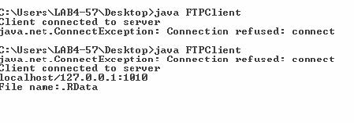

**FTP Server:**

import java.io.DataInputStream;

import java.io.File;

import java.io.FileInputStream;

import java.io.FileOutputStream;

import java.io.PrintStream;

import java.net.ServerSocket;

import java.net.Socket;

public class FTPServer {

public static void main(String[] args)

{

try {

while (true)

{

ServerSocket ss=new ServerSocket(1010);

Socket sl=ss.accept();

System.out.println("Server scoket is created....");

System.out.println(" test1");

DataInputStream fromserver=new DataInputStream(sl.getInputStream());

System.out.println(" test2");

String option=fromserver.readLine();

if (option.equalsIgnoreCase("upload"))

{

System.out.println("upload test");

String filefromclient=fromserver.readLine();

File clientfile=new File(filefromclient);

FileOutputStream fout=new FileOutputStream(clientfile);

int ch;

while ((ch=fromserver.read())!=-1)

{

fout.write((char)ch);

}

fout.close();

}

if (option.equalsIgnoreCase("download"))

{

System.out.println("download test");

String filefromclient=fromserver.readLine();

File clientfile=new File(filefromclient);

FileInputStream fis=new FileInputStream(clientfile);

PrintStream out=new PrintStream(sl.getOutputStream());

int n=fis.read();

while (n!=-1)

{

out.print((char)n);

n=fis.read();

}

fis.close();

out.close();

} //while

}

}

catch (Exception e)

{

System.out.println(e);

// TODO: handle exception

}

}

}

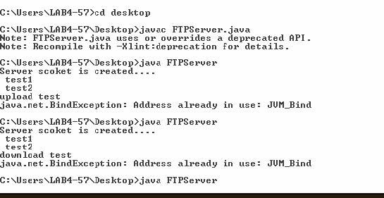



**Implementation of Name Server**

import java.net.*;

import java.io.*;

import java.util.*;

public class DNS

{

public static void main(String[] args)

{

int n;

BufferedReader in = new BufferedReader(new InputStreamReader(System.in));

do

{

System.out.println("\n Menu: \n 1. DNS 2. Reverse DNS 3. Exit \n");

System.out.println("\n Enter your choice");

n = Integer.parseInt(System.console().readLine());

if(n==1)

{

try

{

System.out.println("\n Enter Host Name ");

String hname=in.readLine();

InetAddress address;

address = InetAddress.getByName(hname);

System.out.println("Host Name: " + address.getHostName());

System.out.println("IP: " + address.getHostAddress());

}

catch(IOException ioe)

{

ioe.printStackTrace();

}

}

if(n==2)

{

try

{

System.out.println("\n Enter IP address");

String ipstr = in.readLine();

InetAddress ia = InetAddress.getByName(ipstr);

System.out.println("IP: "+ipstr);

System.out.println("Host Name: " +ia.getHostName());

}

catch(IOException ioe)

{

ioe.printStackTrace();

}

}

}while(!(n==3));

}

}

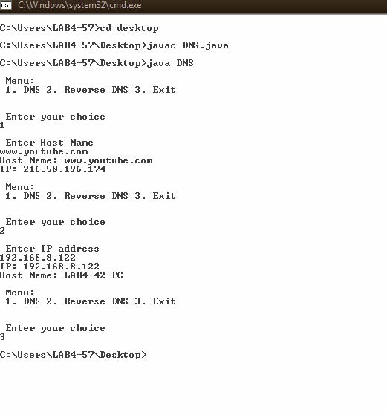

**Implementation of Chat Server**

**CCLogin.java**

import java.awt.Font;

import java.awt.event.ActionEvent;

import java.awt.event.ActionListener;

import java.io.IOException;

import javax.swing.JButton;

import javax.swing.JFrame;

import javax.swing.JLabel;

import javax.swing.JPanel;

import javax.swing.JTextField;

import java.awt.GridLayout;

public class CCLogin implements ActionListener

{

JFrame frame1; JTextField tf,tf1; JButton button;

JLabel heading; JLabel label,label1;

public static void main(String[] paramArrayOfString)

{

new CCLogin();

}

public CCLogin()

{

this.frame1 = new JFrame("Login Page");

this.tf = new JTextField(10);

this.button = new JButton("Login");

this.heading = new JLabel("Chat Server");

this.heading.setFont(new Font("Impact", 1, 40));

this.label = new JLabel("Enter you Login Name");

this.label.setFont(new Font("Serif", 0, 24));

JPanel localJPanel = new JPanel();

this.button.addActionListener(this);

localJPanel.add(this.heading); localJPanel.add(this.label);

localJPanel.add(this.tf);

localJPanel.add(this.button);

this.heading.setBounds(30, 20, 280, 50);

this.label.setBounds(20, 100, 250, 60);

this.tf.setBounds(50, 150, 150, 30);

this.button.setBounds(70, 190, 90, 30);

this.frame1.add(localJPanel);

localJPanel.setLayout(null);

this.frame1.setSize(300,300);

this.frame1.setVisible(true);

this.frame1.setDefaultCloseOperation(3);

}

public void actionPerformed(ActionEvent paramActionEvent)

{

String str = "";

try

{

str = this.tf.getText();

this.frame1.dispose();

Client1 c1= new Client1(str);

c1.main(null);

}

catch(Exception localIOException)

{

}

}

}

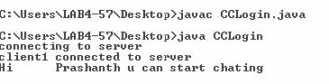

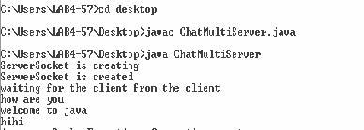

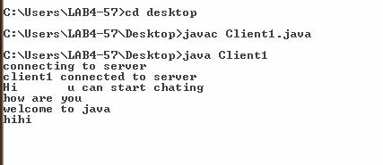

**ChatMultiServer:**

import java.net.*;

import java.io.*;

class A implements Runnable

{

Thread t;

Socket s;

A(Socket x)

{

s=x;

t=new Thread(this);

t.start();

}

public void run()

{

try

{

/* Reading data from client */

InputStream is=s.getInputStream();

byte data[]=new byte[50];

is.read(data);

String mfc=new String(data);

mfc=mfc.trim();

System.out.println(mfc);

/* Sending message to the server */

//System.out.println("Hi"+name+"u can start chating");

BufferedReader br=new BufferedReader(new

InputStreamReader(System.in));

String n=br.readLine();

OutputStream os=s.getOutputStream();

os.write(n.getBytes());

}

catch(Exception e)

{

e.printStackTrace();

}

}

}

class ChatMultiServer

{

static int c=0;

public static void main(String args[]) throws Exception

{

System.out.println("ServerSocket is creating");

ServerSocket ss=new ServerSocket(1010);

System.out.println("ServerSocket is created");

System.out.println("waiting for the client from the client");

while(true)

{

Socket s=ss.accept();

new A(s);

}

}

}

**Client1.java**

import java.net.*;

import java.io.*;

class Client1

{

static String name="";

public Client1(String n)

{

name=n;

}

public static void main(String args[]) throws Exception

{

System.out.println("connecting to server");

System.out.println("client1 connected to server");

BufferedReader br=new BufferedReader(new InputStreamReader(System.in));

/* Sending message to the server */

System.out.println("Hi\t"+name+" u can start chating");

while(true)

{

Socket s=new Socket("localhost",1010);

String n=br.readLine();

OutputStream os=s.getOutputStream();

os.write(n.getBytes());

/* Reading data from client */

InputStream is=s.getInputStream();

byte data[]=new byte[50];

is.read(data);

String mfc=new String(data);

mfc=mfc.trim();

System.out.println(mfc);

}

}

}

**Understanding of Working of NFS (includes exercises Configuration of NFS )**

**Study of Network File Systems**

1. Create a Folder nfs/abc.txt

2. Know the ipaddress

Applications->System Settings->Network—edit ( ipaddress, subnetmask)

(or) In terminal type ifconfig

3. Enable the desired services

1. System Services->Server Settings->Services

• Network (Enable)

• Nfs (Enable)

• Iptables (Disable) (we do not firewalls)

2. System Settings ->Security Level (Firewall options-disable, Selinuxdisable)

**Creation of Network File System Server**

1. System Settings->Server Settings->NFS

+ Add (All are making security levels low)

2. Open Terminal

Type: service nfs restart

Creation of NFS Client

Open terminal

Type: df

Type: mount –t nfs 135.135.5.120:/usr/nfs /root/abc

cd abc

ls : abc.txt

Unmount: umount –t nfs 135.135.5.120:/usr/nfs

Note: service network restart (if n/w is disabled use this )

**Write a program to implement Hello world service using RPC.**

**Publisher.java**

package rpc_helloworld;

import javax.xml.ws.Endpoint;

public class Publisher {

public static void main(String[] args) {

Endpoint.publish("http://localhost:7779/ws/hello", new HelloWorldImpl());

}

}

**RPC_HelloWorld.java**

package rpc_helloworld;

import java.net.MalformedURLException;

import java.net.URL;

import java.util.logging.Level;

import java.util.logging.Logger;

import javax.xml.namespace.QName;

import javax.xml.ws.Service;

public class RPC_HelloWorld {

public static void main(String[] args) {

try {

URL url = new URL("http://localhost:7779/ws/hello?wsdl");

QName qname = new QName("http://rpc_helloworld/", "HelloWorldImplService");

Service service = Service.create(url, qname);

HelloWorld hello = service.getPort(HelloWorld.class);

System.out.println(hello.getHelloWorld("Hello World!"));

} catch (MalformedURLException ex) {

System.out.println("WSDL document url error: " + ex);

}

}

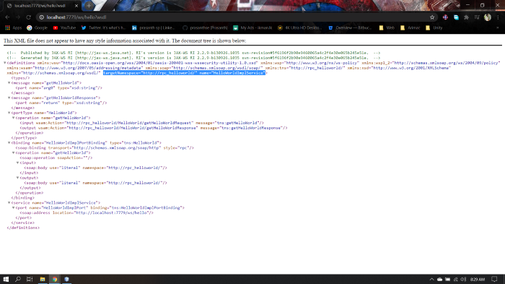}

**Develop an application using 3-tier architectures**



